TurtleBot Assembly Instructions

TurtleBot 2
Includes
- 1x Kobuki Mobile Platform
- 1x Set of Laser Cut Discs
- 1x Set of Base standoffs
- 1x Small Parts Kit
- 1x USB Installer

TurtleBot 2 BOM

Item | QTY | PART NUMBER | DESCRIPTION
1 | 12 | IHE-0103-0340-1001 | M4 x 16mm 0.7mm Pitch Flanged Socket Cap Screw
2 | 2 | IHE-0103-4540-1000 | M4 x 16mm 0.7mm Pitch Knurl Style Thumbscrew
3 | 1 |  | Yujin Robot iCLEBO Kobuki
4 | 1 | IHE-0102-000C-0000 | Turtlebot 2 Disc 1
5 | 1 | IHE-0102-000D-0000 | Turtlebot 2 Disc 2
6 | 1 | IHE-0102-000E-0000 | Turtlebot 2 Disc 3
7 | 6 | IHE-0100-0005-2700 | Turtlebot M-F Standoff – 39.2mm [~1.5in]
8 | 4 | IHE-0100-0003-3300 | Turtlebot M-F Standoff – 50.8mm [2in]
9 | 4 | IHE-0100-0004-CB00 | Turtlebot M-F Standoff – 203.2mm [8in]
10 | 2 | IHE-0100-0007-5300 | Kinect Standoff
11 | 1 | IHE-0A03-0000-0000 | Kinect Sensor
12 | 1 | IHE-0800-0001-0000 | Metric Hex 3.0mm Allen Wrench 2.5in Length
13 | 1 | IHE-0A02-0001-0000 | Turtlebot 2 Laptop [varies by model]
14 | 1 |  | Laptop Charging Cable [varies by model]
15 | 1 |  | Kinect USB and Power Cable
16 | 1 |  | Power Adapter and Power Cord [US, UK, EU, AU]
17 | 1 |  | Turtlebot 2 USB Installer

Detach for Assembly Use
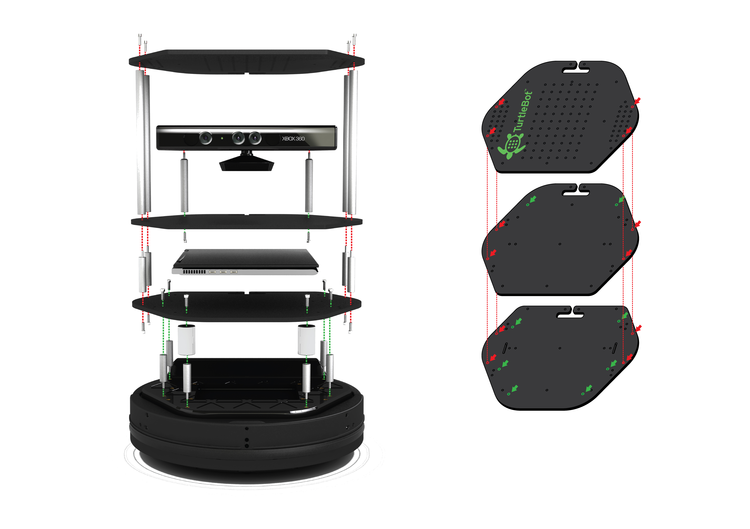
The TurtleBot2 features vertical stack construction. Below, an exploded view of the TurtleBot2's assembly outlines the basics of the process.

STEP 1:
Needed:
Item No. | Qty.
3 | 1
7 | 6

The Kobuki Base has 6 locations where the ~1.5in Standoffs are fastened.
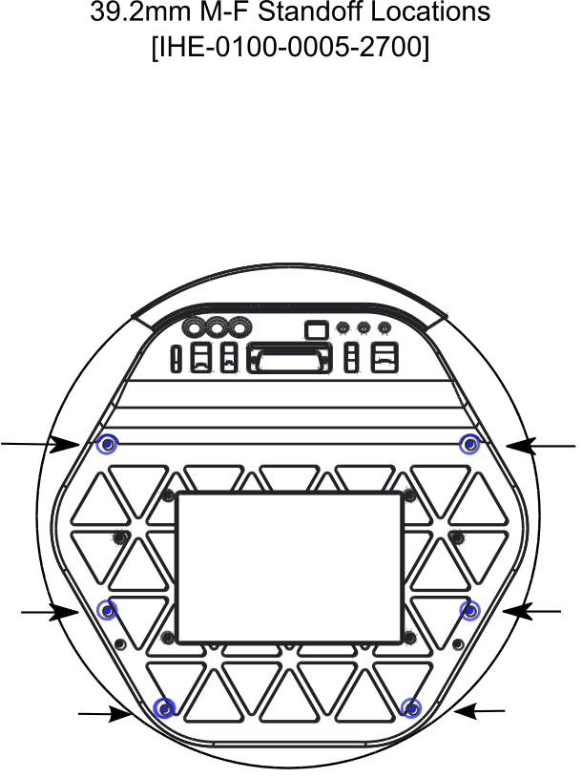
Fasten the Standoffs to the Kobuki Base in the locations illustrated by the drawing. Done properly, the base should now resemble the picture below:

STEP 2:
Needed:
Item No. | Qty
1 | 6
4 | 1
12 | 1

Place Disc1 on top of the standoffs and fasten using 6 of your M4 screws. Refer to the pictures for reference.

